6/28/2022

**Bahria University Karachi**

**Report**

**Database Management System**

**Assignment No 3**

Group Members:

**Ali Gauhar (02-134202-006)**

**Muhammad Hashim (02-134202-114)**

**Naeem-Ur-Rehman (02-134202-053)**

Class: **BS(CS) – 4A**

Department of Computer Science

**Bahria University Karachi**

**Theory Assignment Report**

**Purpose:**

1. **Creating an Entity-Relationship Diagram for Job Seeker and Employer affiliated with a Website (Monster) managed by an Admin.**
2. **This ERD can be used to create and manage a database for Job Hunting Websites.**
3. **The basic need to make this system is to connect Employer with the Employee automatically**

**Creation of ERD:**

Each entity used in the ERD is analyzed in every possible way. **Business Rules** are defined, **Relationships** are made between them and normalized

**Summary**

First of all, our team would like to thank Sir Malik Ali for giving us such an advance knowledge about Data Base due to which we are able to accomplish this task.

After deep analyzation of monster website, we found that the entities are covering three major sides that are employer, Job Seeker an Admin but after working on the task we found that it is covering two more major parts that are matching engine and job Seeker setting

Matching engine:

Here we are considering that the data base has all the name of fields and its key words defined already that an employer or jobseeker can use, whenever the job seeker sign in and put his info in the data Base, a query will run and analyze the resume description and job seeker preferences, settings, experiences etc. to find the keywords, then it will match that key words to the existing table to find which job is most matched and then in a new table all the matched jobs and their percentages will be stored, same with the employer whenever the employer sign a query will run and analyze it on the basis of data provided by employer, now the main thing that how will both employer and job seeker match?

For this purpose a new table will be created that will take the matched employer and job seeker against the field that they are ranking , and it will be ranked when ever search query or alert message query is triggered, following flow will explain you more about it.

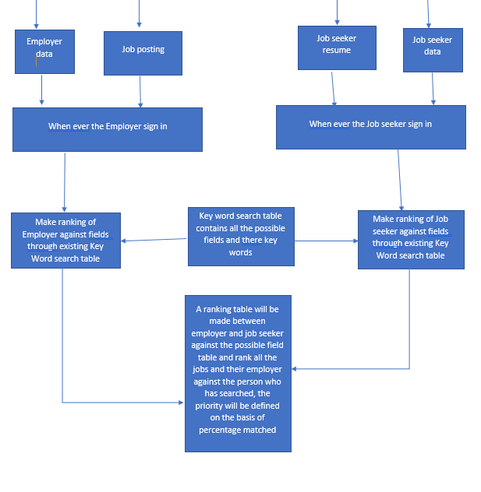

**Entity-Relationship Diagram**

**Job Portal**

**Business Rules:**

1. All the key words must be pre-defined for SEO like below
2. Job portal must contain the matching criteria of Jobseeker
3. Job portal must contain the matching criteria of employer

Sample Matching List:

|  |  |  |
| --- | --- | --- |
| **Ranking ID** | **Field Name** | **Key words** |
| #3456 | Cyber security | Soc analyst, bug bounty, hacker, penetration testing, etc. |
| #3457 | Web development | BSCS, frontend developer, backend developer, full stack developer, etc. |
| #3458 | Block chain development | BSCS, frontend developer, backend developer, full stack developer, smart contracts, etc. |
| #3459 | SEO | SEO web, SEO app, etc. |

1. Portal search results for keywords, alerts, feed on job portal
2. Matching jobs can be found by alerts, SMS, job portal

Sample Matching Result for Job:

|  |  |  |  |
| --- | --- | --- | --- |
| **Employer no** | **Jobseeker no** | **% of match** | **Portal matching ID** |
| #8979 | #7979 | 82% | 1 |
| #8980 | #7979 | 62% | 2 |
| #8979 | #7950 | 23% | 3 |

1. Job Seeker can search for any post
2. Ranking will be done based on (preferences, alerts for, skills, previous jobs, education, location)

Sample Matching Result for Job:

|  |  |  |  |  |  |  |  |  |
| --- | --- | --- | --- | --- | --- | --- | --- | --- |
| **preferences** | **alerts** | **skills** | **Previous job** | **education** | **location** | **jobseeker** **no** | **Ranking ID (multivalued)** | **% of match** |
| IT | Cyber security | Bug bounty | SOC analyst | BSCS | Karachi | #7979 | #3456 | 82% |
| Electrical | SEO specialist | Data base,SEO | SOC analyst | BSCS | Karachi | #7979 | #3456 | 18% |
| Electrical | SEO specialist | Data base,SEO | SOC analyst | BSCS | Karachi | #7979 | #3456 | 58% |

1. Employer can search for Job Seeker
2. Ranking will be done based on (industry, description, skills required , Roll, company location)

Sample Employer Matching Criteria:

|  |  |  |  |  |  |  |  |
| --- | --- | --- | --- | --- | --- | --- | --- |
| **industry** | **Description (a query will search for the required words in description)** | **Skills**  **required** | **roll** | **Company location** | **employer no** | **Ranking ID (multivalued)** | **of match** |
| IT | Cyber security, defensive side | Bug bounty | SOC analyst | Karachi | #8979 | #3456 | 82% |
| IT | Frontend developer, block chain developer | Smart contracts | Null | Karachi | #8979 | #3457 | 76% |
| IT | Frontend developer, block chain developer | Smart contracts | Null | Karachi | #8979 | #3457 | 76% |
| IT | SEO | SEO | Null | Karachi | #8980 | #3459 | 90% |

**Job Seeker**

**Business Rules:**

1. Job seeker can directly communicate with the employer if chat is allowed
2. Employee can find job manually on portal
3. Job seeker can make multiple Resume
4. One resume belongs to only one job seeker
5. Job seeker can have multiple Experiences/ one resume can have multiple experiences written in it
6. One experience can have multiple Job Seeker/ one experience can be written in it multiple resume
7. Job seeker can have multiple matching criteria
8. One matching criterion can have one job Seeker
9. Job seeker can have multiple locations
10. Location can have multiple Job Seeker
11. Job seeker can have multiple emails
12. One email can have one Job Seeker
13. Job seeker can have multiple certification
14. Certification can have multiple Job Seeker
15. Job seeker can have multiple awards
16. Awards can have multiple Job Seeker
17. Job seeker can have multiple educations
18. Education can have multiple job seekers
19. Job seeker can have single name
20. One name can belong to multiple Job Seeker
21. Job seeker can have single ID
22. One Id can have one job Seeker
23. Job seeker can have single Password
24. One password can belong to one Job Seeker
25. Job seeker can have single settings
26. Setting can have one job seeker

Entity: Resume

1. Resume has multiple Cocurricular Activities
2. One Cocurricular Activities can belong to multiple resume
3. Resume has multiple Work Authorization
4. One work authorization has multiple resume
5. Resume has multiple Skills
6. One skill can be present in multiple resume
7. Resume one Work Phone No
8. One phone no can not be present multiple resume
9. Resume has multiple Work Emails
10. One email cannot be present in multiple resume

Entity: Experience

1. Job Seeker has multiple experiences
2. One experience can belong to multiple Job seeker
3. Experience has one job title
4. One job title can belong to one experience
5. Experience has one Description
6. One description can have one experience
7. Experience has one job Achievement
8. Achievement has one Experience
9. Experience has one Starting Date
10. Experience has one Ending Date
11. Experience has one Company Name
12. Experience has one Location

Entity: Location

1. Location has one Country
2. Location has one State
3. Location has one Zip

Entity: Certificate

1. Certification has date
2. Certification has one Summary
3. Certification has one name

Entity: Award

1. Award has one name
2. Award has one description

Entity: Education

1. Education has one starting date
2. Education has one ending date
3. Education has one degree name
4. Education has one degree Type
5. Education has one School Name
6. Education has one Location

Entity: Name

1. Name has one First name
2. Name has one last name
3. Name has one pronunciation

**Settings**

**Business Rules:**

1. Setting can have single account management options
2. Setting can have multiple alerts
3. One alert can belong to multiple settings
4. Setting can have multiple compensation targets
5. One compensation target can have multiple settings
6. Setting can have single privacy setting
7. Setting can have single communication setting

Entity: Account Management

1. Account Management (change password ) store previous single passwords
2. Can send single request for account deletion

Entity: Preferences/Alerts

1. If alerts are allowed, then send SMS on job matching
2. Alerts have single Job title
3. Alerts have multiple Location
4. Alerts have single allow alert option

Entity: Compensation Targets

1. Job Seeker can have multiple compensation-Targets
2. One compensation-Targets can have multiple job Seekers
3. Compensation targets has an influence on job match
4. Compensation-Target contains
5. Currencies
6. job type
7. payments
8. ideal salary

**Communication**

**Business Rules:**

1. Multiple users can Communication with monster
2. One admin can deal with multiple user
3. Multiple SMS communication can be done to users
4. Multiple users can get same message

Entity: Communication with Monster

1. Admin, jobseeker, and employer can communicate to monster
2. User with paid subscription will be able to get the career advice and private opportunities through admin
3. Any update from admin will be directly communicated to the employer and jobseeker
4. Communication has multiple updates on web portal
5. Users get multiple career advice through admin
6. One career advice can be given to multiple users
7. Users get multiple private opportunity through admin
8. One private opportunity can be given to multiple users

Entity: SMS Communication

1. If alerts are allowed, then send SMS on job matching then auto job match alert
2. If text messaging to employer is enabled, then allow the chat between them
3. Allow emp to text
4. Allow auto match alert

Entity: Privacy

1. If hide work authorization is enabled, then hide from portal
2. If hide name is enable, then hide name while job match
3. Allow visibility to employer
4. Hide Work Authorization
5. Hide Name

**Admin**

**Business Rules:**

1. Admin, jobseeker, and employer can communicate to monster
2. User with paid subscription will be able to get the career advice and private opportunities through admin
3. We are considering that the website is handled by only one admin
4. Any update from admin will be directly communicated to the employer and jobseeker
5. Admin can handle the maintenance multiple features of websites
6. Admin can communicate with multiple users through monster communication
7. Admin can approve many accounts for deletion
8. Admin can manage multiple announcements

Entity: Announcement

1. Can have multiple Additional features
2. Can undergo 1 Maintenance at a time ( This is a check for showing a note on the top when the website is undergoing maintenance)

**Employer**

**Business Rules:**

1. There can be multiple preferred locations in Settings or there could be None. While 1 preferred location can only be used by a single setting
2. A setting may contain a least 1 payment Type or there could be many.
3. A payment method will contain at least 1 PayPal ID or Many while a single PayPal info will only be stored in a single payment method
4. A payment method will contain many credit card information or at least 1 information while 1 credit card info will only be stored in 1 only payment method
5. A payment method will contain at least 1 PayPal ID or Many while a single PayPal info will only be stored in a single payment method
6. A setting may contain a least 1 payment Type or there could be many

**Functional Dependencies**

**Before Normalization**

**Admin** ( **Admin_login_ID**, Password, **Announcement_ID**, Additional_Features, **Communication_ID**, Update_Text, Career_Advice_Text, Private_Opportunity_Text)

**JobSeeker** ( **JS_Login_ID**, JS_FirstName, JS_LastName, JS_Pronunciation, Password, Email, Co_Curricular_Activity, AuthorizedFor, **Q_ID**, **ExistingQuestion**, QuestionName, QuestionIntro, QuestionResponse, QuestionPointValues, **Emp_Login_ID**, Emp_FirstName, Emp_LastName, Emp_Pronunciation, **AwardsID**, AwardName, AwardDescription, **CertificationID**, CertificateName, CertificateMonthsRequired, CertificateYearsRequired, CertificateSummary, **ExperienceID**, E_JobTitle, E_Description, E_Achievement, E_StartDate, E_EndDate, E_CompanyName, **LocationID**, **Country**, State, ZIP, **EducationID**, Edu_StartDate, Edu_EndDate, Edu_SchoolName, Edu_DegreeName, Edu_DegreeType, **SettingsID**, AllowVisibilitytoEmployer, HideWorkAuthorization, HideName, **ChatID**, Chats)

**Settings** ( **Setting_ID**, Change_Password, **Currency**, IdealSalary, **Communication_ID**, Update_Text, Career_Advice_Text, Private_Opportunity_Text, **Preferences/Alerts_ID**, JobTitle, AllowAlert, EmployerSMS, AutoMatchAlertSMS, **BudgetID**, PreferedJob, FrequentPaymentBudget, PreferedBudgetJobs

**JobPortal** ( **Match_Ranking_ID**, Field_Name, Match_Ranking_Key_Words, PercentageOfMatching, **JS_Login_ID**, JS_FirstName, JS_LastName, JS_Pronunciation, **Emp_Login_ID**, Emp_FirstName, Emp_LastName, Emp_Pronunciation, **KeyWordID**, KeyWords, ExcludedKeyWords)

**Employer** ( **Emp_Login_ID**, Emp_FirstName, Emp_LastName, Emp_Pronunciation, PhoneNo, Password, **LocationID**, **Country**, State, ZIP, **CompanyID**, Company_Name, Company_AreaofService, Company_Industry, Company_Products, Company_Description, **SettingsID**, EnableDrag&Drop, RecieveApplicationsinEmail, OriginalFormat, PreferedCountries, ChangePassword, **JS_Login_ID**, JS_FirstName, JS_LastName, JS_Pronunciation, **JP_ID**, JobDescriptionID, Title, RefCode, JobSummary, JobDescription, JobRoleRequired, JobExperienceRequired, JobEducationRequired, JobNationalityRequired, JobIndustry, JobCategory, JobWorkingHours, JobShift, JobSkillsRequired, **Salary**, Currency, Min, Max, **PersonalFolder**, FolderDate, FolderName, **Q_ID**, **ExistingQuestion**, QuestionName, QuestionIntro, QuestionResponse, QuestionPointValues, **PaymentID**, **PayPal_ID**, **Credit_ID**, ExpiryDate, BankName, CVV, PayPal_Email, **PEL_ID**, PreferedLocation, **FilterID**, ShowResumeOnly)

**First Normalized Form**

**Admin** ( **Admin_login_ID**, Password, **Announcement_ID**, Additional_Features, **Communication_ID**, Update_Text, Career_Advice_Text, Private_Opportunity_Text)

**JobSeeker** ( **JS_Login_ID**, JS_FirstName, JS_LastName, JS_Pronunciation, Password, AuthorizedFor, **Q_ID**, **ExistingQuestion**, **Emp_Login_ID**, **AwardsID** AwardDescription, , **ExperienceID**, **LocationID**, **EducatioID**, **SettingsID**, AllowVisibilitytoEmployer, HideWorkAuthorization, HideName, **ChatID**)

**Education**(**EducatioID** ,Edu_StartDate, Edu_EndDate, Edu_SchoolName, Edu_DegreeName, Edu_DegreeType)

**Email**(**JS_Login_ID**, Email)

**Co_Curricular_Activity** (**JS_Login_ID**, Co_Curricular_Activity)

**Award**(**AwardsID**, AwardName)

**Certifications**(**CertificationID**, CertificateName,CertificateMonthsRequired, CertificateYearsRequired, CertificateSummary)

**Experiences**(, **ExperienceID,** E_JobTitle, E_Description, E_Achievement, E_StartDate, E_EndDate, E_CompanyName,**)**

**Location**(**LocationID**, **Country**, State, ZIP,)

**Chat**(**ChatID**, Chats)

**Settings** ( **Setting_ID**, Change_Password, **Currency**, IdealSalary, **Communication_ID**, Update_Text, Career_Advice_Text, Private_Opportunity_Text, **Preferences/Alerts_ID**, JobTitle, AllowAlert, EmployerSMS, AutoMatchAlertSMS, **BudgetID**)

**Budget**(**BudgetID**, PreferedJob, FrequentPaymentBudget, PreferedBudgetJobs)

**JobPortal** ( **Match_Ranking_ID**, **JS_Login_ID**, JS_FirstName, JS_LastName, JS_Pronunciation, **Emp_Login_ID**, Emp_FirstName, Emp_LastName, Emp_Pronunciation, **KeyWordID**, KeyWords, ExcludedKeyWords)

**Rankings**(**Match_Ranking_ID**, Field_Name, Match_Ranking_Key_Words, PercentageOfMatching)

**Employer** ( **Emp_Login_ID**, Emp_FirstName, Emp_LastName, Emp_Pronunciation, PhoneNo, Password, **LocationID**, **CompanyID**, Company_Name, Company_AreaofService, Company_Industry, Company_Products, Company_Description, **SettingsID**, EnableDrag&Drop, RecieveApplicationsinEmail, OriginalFormat, PreferedCountries, ChangePassword, **JP_ID**, **Salary**, **PaymentID , PersonalFolder**, **Q_ID**, **PEL_ID**, PreferedLocation, **FilterID**, ShowResumeOnly)

**Location**(**LocationID**, **Country**, State, ZIP)

**Job** **Posting**(**JP_ID**, JobDescriptionID, Title, RefCode, JobSummary, JobDescription, JobRoleRequired, JobExperienceRequired, JobEducationRequired, JobNationalityRequired, JobIndustry, JobCategory, JobWorkingHours, JobShift, JobSkillsRequired)

**Salary**(**Salary**, Currency, Min, Max,)

**Folders(PersonalFolder**, FolderDate, FolderName)

**Questions**(**Q_ID**, **ExistingQuestion**, QuestionName, QuestionIntro, QuestionResponse, QuestionPointValues)

**Payment**(**PaymentID**)

**Credit** **card**(**PaymentID**, **Credit_ID**, ExpiryDate, BankName, CVV)

**PayPal**(**PaymentID ,PayPal_ID**, PayPal_Email)

**Second Normalized Form**

**Admin** ( **Admin_login_ID**, Password, **Communication_ID**, **Announcement_ID**,)

**Announcement**(**Announcement_ID**, Additional_Features)

**Communiation**(**Communication_ID**, Update_Text, Career_Advice_Text, Private_Opportunity_Text)

**JobSeeker** ( **JS_Login_ID**, **Q_ID**, **ExistingQuestion**, **Emp_Login_ID**, **AwardsID**, **ExperienceID**, **LocationID**, **EducatioID**, **ChatID, SettingsID**)

**JobSeekerInfo**(**JS_Login_ID**, JS_FirstName, JS_LastName, JS_Pronunciation, Password, AuthorizedFor)

**Settings**(**SettingsID**, AllowVisibilitytoEmployer, HideWorkAuthorization, HideName,)

**Education**(**EducatioID** ,Edu_StartDate, Edu_EndDate, Edu_SchoolName, Edu_DegreeName, Edu_DegreeType)

**Email**(**JS_Login_ID**, Email)

**Co_Curricular_Activity** (**JS_Login_ID**, Co_Curricular_Activity)

**Award**(**AwardsID**, AwardName)

**Certifications**(**CertificationID**, CertificateName,CertificateMonthsRequired, CertificateYearsRequired, CertificateSummary)

**Experiences**( **ExperienceID,** E_JobTitle, E_Description, E_Achievement, E_StartDate, E_EndDate, E_CompanyName)

**Location**(**LocationID**, **Country**, State, ZIP)

**Chat**(**ChatID**, Chats)

**Settings** ( **Setting_ID**, Change_Password, **Currency**, IdealSalary, **ID,** **Preferences/Alerts_ID**, **BudgetID**)

**Preferences (Preferences/Alerts_ID**, JobTitle, AllowAlert, EmployerSMS, AutoMatchAlertSMS)

**Budget** (**BudgetID**, PreferedJob, FrequentPaymentBudget, PreferedBudgetJobs)

**Communication** (**Communication_ID**, Update_Text, Career_Advice_Text, Private_Opportunity_Text,)

**JobPortal** ( **Match_Ranking_ID**, **JS_Login_ID**, **Emp_Login_ID**, Emp_FirstName, Emp_LastName, Emp_Pronunciation, **KeyWordID**)

**Ranking** ( **KeyWordID**, KeyWords, ExcludedKeyWords)

**Rankings**(**Match_Ranking_ID**, Field_Name, Match_Ranking_Key_Words, PercentageOfMatching)

**Employer** ( **Emp_Login_ID**, Emp_FirstName, Emp_LastName, Emp_Pronunciation, PhoneNo, Password, **LocationID**, **CompanyID**, **SettingsID**, **JP_ID**, **Salary**, **PaymentID , PersonalFolder**, **Q_ID)**

**Filter**(**SettingsID , FilterID**, ShowResumeOnly)

**Prefered** **Location**(**SettingsID** , **PEL_ID**, PreferedLocation)

**Settings**(**SettingsID**, EnableDrag&Drop, RecieveApplicationsinEmail, OriginalFormat, PreferedCountries, ChangePassword)

**Company (CompanyID**, Company_Name, Company_AreaofService, Company_Industry, Company_Products, Company_Description)

**Location**(**LocationID**, **Country**, State, ZIP)

**Job** **Posting**(**JP_ID**, JobDescriptionID, Title, RefCode, JobSummary, JobDescription, JobRoleRequired, JobExperienceRequired, JobEducationRequired, JobNationalityRequired, JobIndustry, JobCategory, JobWorkingHours, JobShift, JobSkillsRequired)

**Salary**(**Salary**, Currency, Min, Max,)

**Folders(PersonalFolder**, FolderDate, FolderName)

**Questions**(**Q_ID**, **ExistingQuestion**, QuestionName, QuestionIntro, QuestionResponse, QuestionPointValues)

**Payment**(**PaymentID**)

**Credit** **card**(**PaymentID**, **Credit_ID**, ExpiryDate, BankName, CVV)

**PayPal**(**PaymentID ,PayPal_ID**, PayPal_Email)

**Third Normalized Form**

**Admin** ( **Admin_login_ID**, Password, **Communication_ID**, **Announcement_ID**,)

**Announcement**(**Announcement_ID**, Additional_Features)

**Communiation**(**Communication_ID**, Update_Text, Career_Advice_Text, Private_Opportunity_Text)

**Resume** ( **JS_Login_ID**, **Q_ID**, **ExistingQuestion**, **Emp_Login_ID**, **AwardsID**, **ExperienceID**, **LocationID**, **EducatioID**, **ChatID, SettingsID**)

**JobSeeker**(**JS_Login_ID**, JS_FirstName, JS_LastName, JS_Pronunciation, Password)

Authorization(**JS_Login_ID**, AuthorizedFor)

**Settings**(**SettingsID**, AllowVisibilitytoEmployer, HideWorkAuthorization, HideName,)

**Education**(**EducatioID** ,Edu_StartDate, Edu_EndDate, Edu_SchoolName, Edu_DegreeName, Edu_DegreeType)

**Email**(**JS_Login_ID**, Email)

**Co_Curricular_Activity** (**JS_Login_ID**, Co_Curricular_Activity)

**Award**(**AwardsID**, AwardName)

**Certifications**(**CertificationID**, CertificateName,CertificateMonthsRequired, CertificateYearsRequired, CertificateSummary)

**Experiences**( **ExperienceID,** E_JobTitle, E_Description, E_Achievement, E_StartDate, E_EndDate, E_CompanyName)

**Location**(**LocationID**, **Country**, State, ZIP,)

**Chat**(**ChatID**, Chats)

**Settings** ( **Setting_ID**, Change_Password,**Preferences/Alerts_ID**, **BudgetID**)

Currency(**Currency**, IdealSalary)

**Preferences (Preferences/Alerts_ID**, JobTitle, AllowAlert, EmployerSMS, AutoMatchAlertSMS)

**Budget** (**BudgetID**, PreferedJob, FrequentPaymentBudget, PreferedBudgetJobs)

**Communication** (**Communication_ID**, Update_Text, Career_Advice_Text, Private_Opportunity_Text)

**JobPortal** ( **Match_Ranking_ID**, **JS_Login_ID**, **Emp_Login_ID**, Emp_FirstName, Emp_LastName, Emp_Pronunciation, **KeyWordID**)

**Ranking** ( **KeyWordID**, KeyWords, ExcludedKeyWords)

**Rankings**(**Match_Ranking_ID**, Field_Name, Match_Ranking_Key_Words, PercentageOfMatching)

**Employer** ( **Emp_Login_ID**, Password, **LocationID**, **CompanyID**, **SettingsID**, **JP_ID**, **Salary**, **PaymentID , PersonalFolder**, **Q_ID)**

**Filter**(**SettingsID , FilterID**, ShowResumeOnly)

**Prefered** **Location**(**SettingsID** , **PEL_ID**, PreferedLocation)

**Settings**(**SettingsID**, EnableDrag&Drop, RecieveApplicationsinEmail, OriginalFormat, PreferedCountries, ChangePassword)

**Company (CompanyID**, Company_Name, Company_AreaofService, Company_Industry, Company_Products, Company_Description)

**Location**(**LocationID**, **Country**, State, ZIP)

**Job** **Posting**(**JP_ID**, JobDescriptionID, Title, RefCode, JobSummary, JobDescription, JobRoleRequired, JobExperienceRequired, JobEducationRequired, JobNationalityRequired, JobIndustry, JobCategory, JobWorkingHours, JobShift, JobSkillsRequired)

**Salary**(**Salary**, Currency, Min, Max,)

**Folders(PersonalFolder**, FolderDate, FolderName)

**Questions**(**Q_ID**, **ExistingQuestion**, QuestionName, QuestionIntro, QuestionResponse, QuestionPointValues)

**Payment**(**PaymentID**)

**Credit** **card**(**PaymentID**, **Credit_ID**, ExpiryDate, BankName, CVV)

**PayPal**(**PaymentID ,PayPal_ID**, PayPal_Email)

**Complete ERD Link**

[**https://pern-my.sharepoint.com/:u:/g/personal/01-134202-041_student_bahria_edu_pk/EYs4Q24aDSNIlBX4_OsIKNIBsSyMXmwwpPo96jAbfWGdCQ?rtime=NW2VAjJb2kg**](https://pern-my.sharepoint.com/:u:/g/personal/01-134202-041_student_bahria_edu_pk/EYs4Q24aDSNIlBX4_OsIKNIBsSyMXmwwpPo96jAbfWGdCQ?rtime=NW2VAjJb2kg)

**ERD: Whole View**

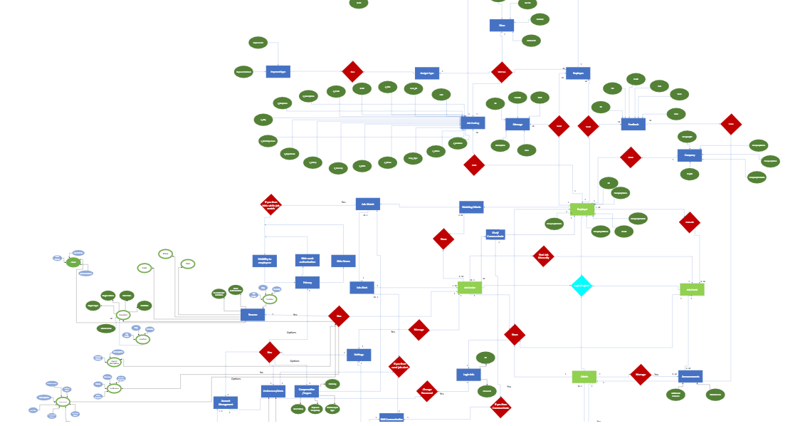

**ERD: Job Seeker Related Entities and Attributes**

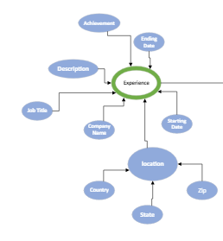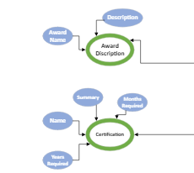

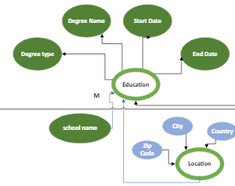 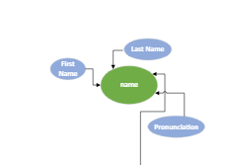 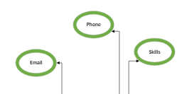 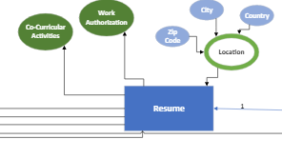

**ERD: Job Seeker Setting Related Entities and Attributes**

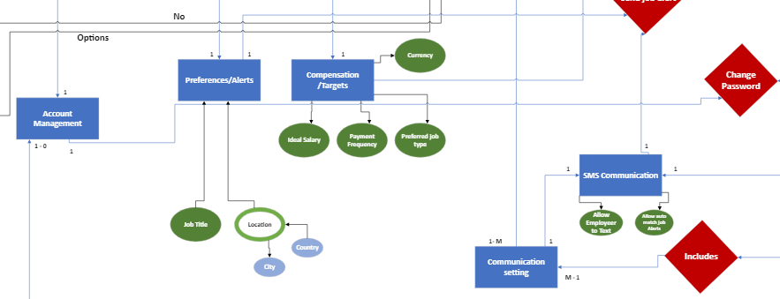

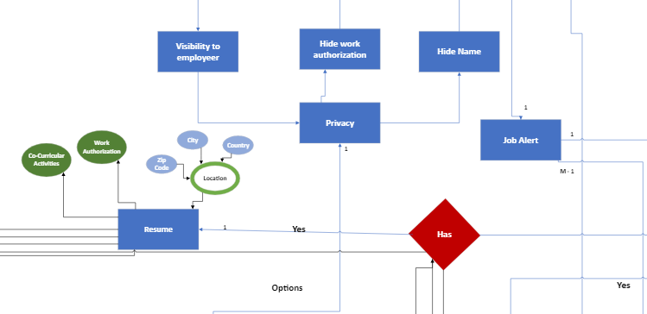

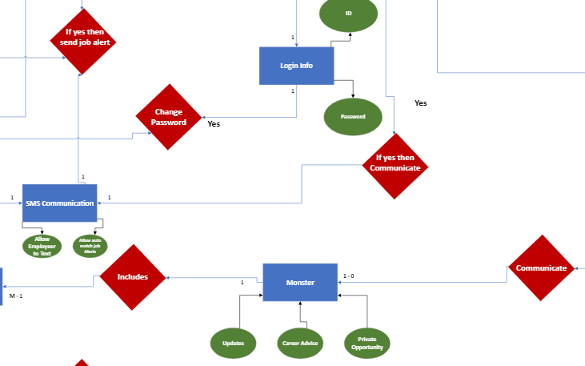

**ERD: Employer**

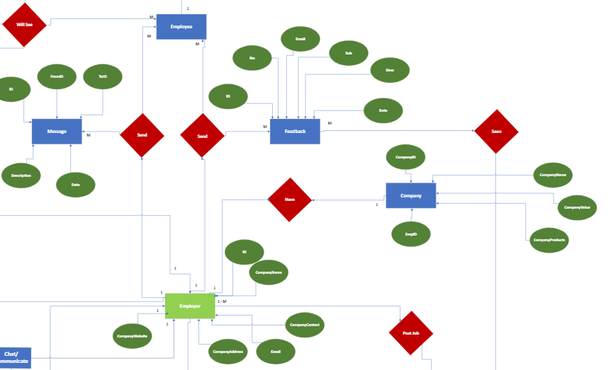

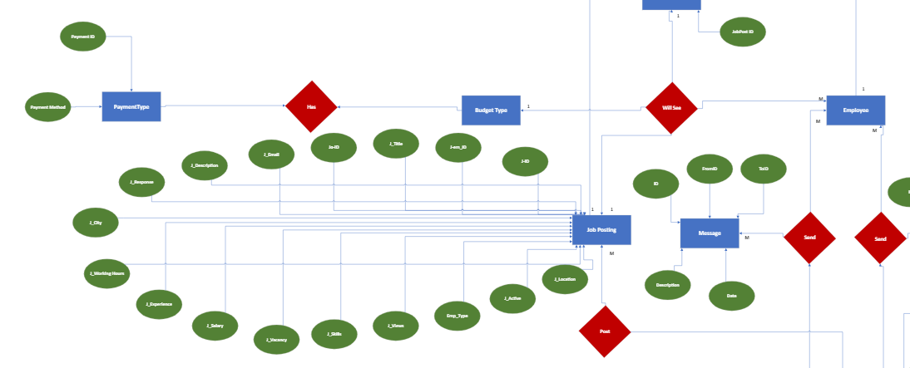

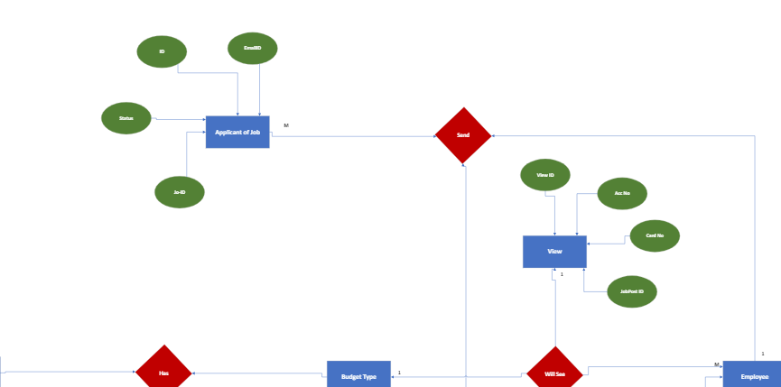

**ERD: Job Portal**

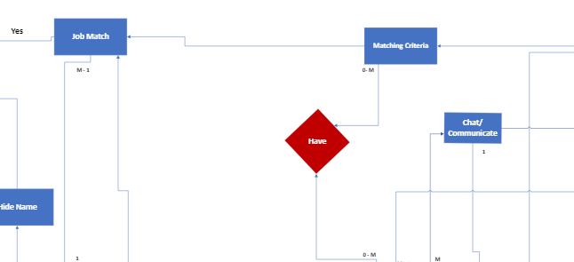



**ERD: Admin**

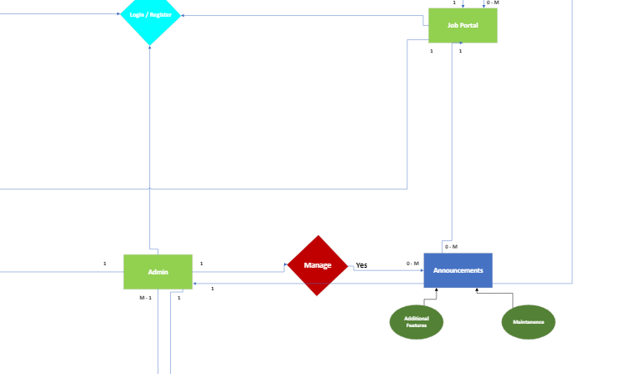

**Complete SCHEMA Link**

[**https://drive.google.com/file/d/14dmVSKeCKUjz8PqdvLql47iXbLerFJkF/view?usp=sharing**](https://drive.google.com/file/d/14dmVSKeCKUjz8PqdvLql47iXbLerFJkF/view?usp=sharing)

**Schema: Overall view**

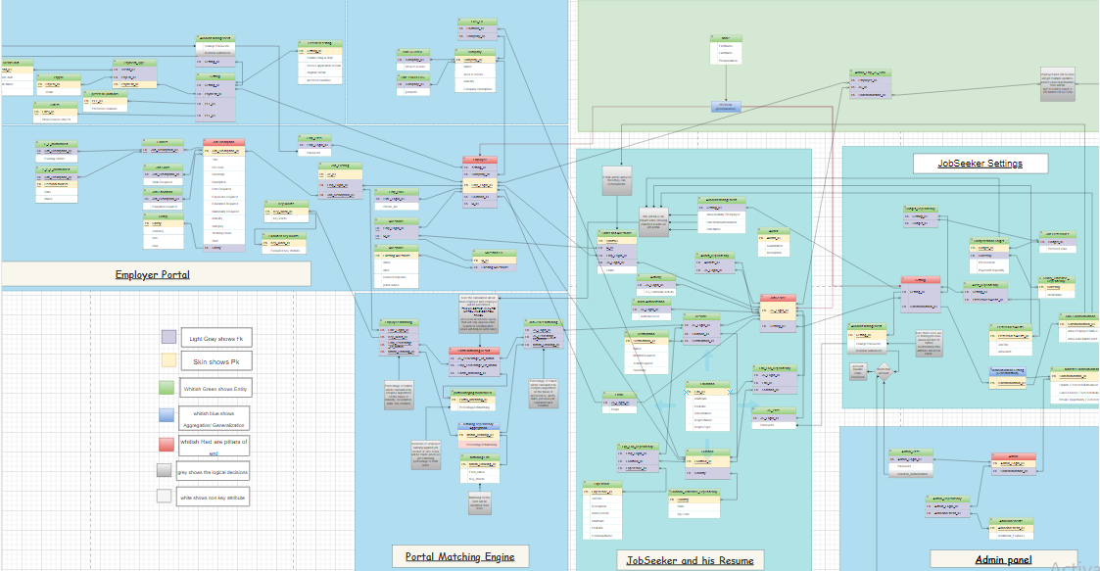

**Schema: Settings and Communication:**

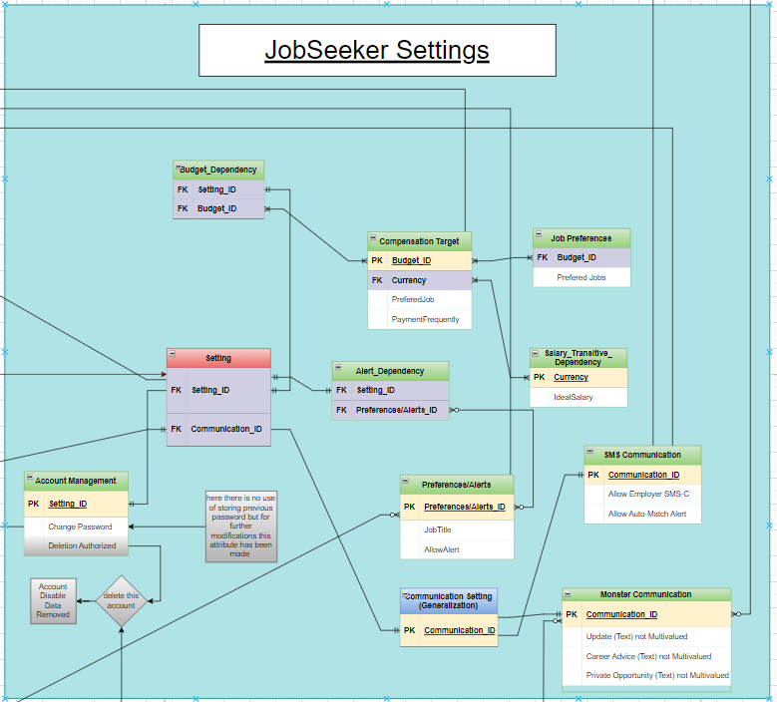

**Schema: Admin:**

**Schema: Jobseeker:**

**Schema: Resume:**

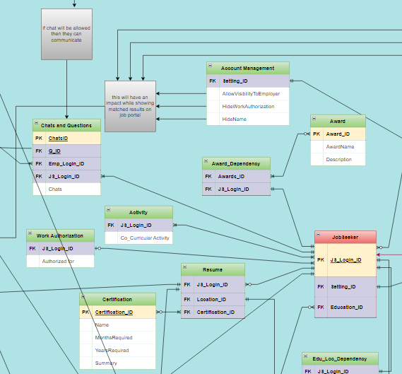

**Schema: Job Portal:**

**Schema: Employer:**

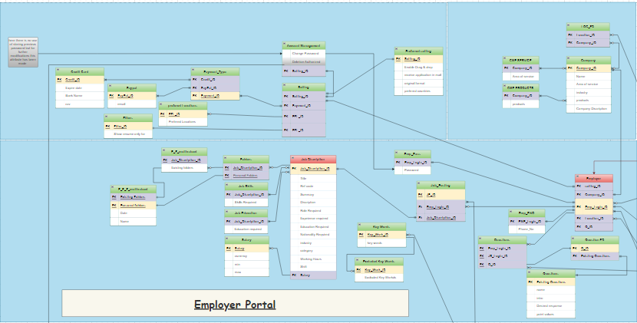

Hosted on GitHub:

<https://github.com/aligauhar/Data-Base-ERD-OF-Monster-Job-Hunting-Site.git>

